QUESTIONS? PLEASE CALL 407-518-8140
Underage GED Process
SCHOOL DISTRICT OF OSCEOLA COUNTY

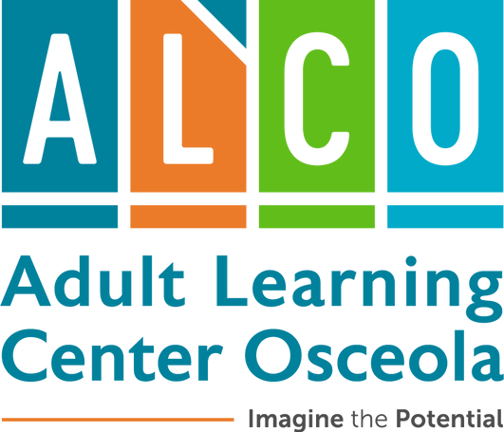
Two Paths to receive an Underage Waiver to test
Path 1: Enroll in ALCO and attend a GED® class for at least 12 hours.
Path 2: Take and pass all 4 GED® ready tests in a proctored environment
These options are available for students who are between 16 or 17 years old. See below for more details on the two diﬀerent paths to the same result: A Florida High School Diploma through the GED® exam.

Follow the directions below to choose this path.
Recommended Option: Enroll in ALCO
- If enrolled in a K-12 school, unenroll from the school prior to applying at ALCO.
- Complete the online registration process at ALCO including payment.
- Schedule and take a placement test.
- Attend the underage orientation with a parent or guardian.
- Attend class- at least 12 hours. Some students will need longer.
- Take the GED® ready test- your teacher will help you know when!
- Your teacher will ensure you have a submitted underage waiver prior to testing and will issue you a ½ price voucher for the GED® test- a savings of $64.00.
- Continue to attend class and test until a 145 has been earned on all 4 GED® tests.
- Sign up for our semi-annual Graduation ceremony with our College and Career Navigators.

  - Sign up for a GED®.com account at home.
Follow the directions below to choose this option
Proctored Exam Option
  - Call the ALCO oﬃce and schedule a time for proctored GED® tests with the GED® lab at ALCO. Two tests can be scheduled for each testing session. All four tests will require two sessions to administer.
  - Each test costs $5.00 to proctor, for a total of $20.00. The student will pay for a voucher for the four tests which costs 24.00 Payment to ALCO will be $44.00 at /or prior to the time of testing. Only tests proctored at ALCO count for an underage waiver.
  - Take all 4 ® GED® Ready tests in one of our labs and score at least a 145.
  - Make an in-person appointment to speak with Karen Combs, Principal, Michelle Overstreet, Assistant Principal, Main Campus, Tiﬀany Bell, Assistant Principal, Poinciana Campus or Tiﬀany Chappel Proctor, School Counselor. A parent and/or guardian must attend in person. Copies of the printed scores will be provided by the testing proctor when the last test is completed.
The student must bring these to the meeting. All Ready tests must be at a 145 to continue. This meeting MUST occur prior to withdrawing from a K-12 school.
  - Withdraw from your school and submit paperwork to ALCO.
  - Age waiver will be signed. Please plan on at least 5 business days to ensure the age waiver will be approved by the state of Florida.
  - Schedule, pay for and take all 4 GED® tests at ALCO. ($32.00 per test)
Please note- there is no graduation option for this choice. The diploma will be mailed to the student’s home from GED® .
For questions, please don’t hesitate to contact the Adult Learning Center Osceola
at 407-518-8140 , Patricia Herman, Testing Coordinator at patricia.herman@osceolaschools.net Tiﬀany Chappel Proctor, School Counselor at Tiﬀany.ChappelProctor@osceolaschools.net

